- Watch ansible-02 video and write down notes.
Completed
- Install httpd using ansible playbook, use handlers, notifiers.
Requirement:
To install apache on servers using ansible playbooks from ansible controller
Deploy one index.html file
Restart my apache2 service
Create one directory under ubuntu user
mkdir playbooks -> cd playbooks/ -> vi apache.yml
Create one file under ubuntu/playbooks
vi index.html -> add text ->save & exit
playbooks:
---
- hosts: all
become: yes
tasks:
- name: install apache
apt:
name: apache2
state: latest
register: apache_status
- name: debug apache installation result
debug:
var: apache_status
- name: copy index.html
copy:
src: index.html
dest: /var/www/html
notify: restart apache2
register: copy_status
- name: debug copy result
debug:
var: copy_status
handlers:
- name: restart apache2
service:
name: apache2
state: restarted
To check the syntax:
ansible-playbook apache.yml --syntax-check
To dry run playbook:
ansible-playbook apache.yml --check
To run playbook:
ansible-playbook apache.yml
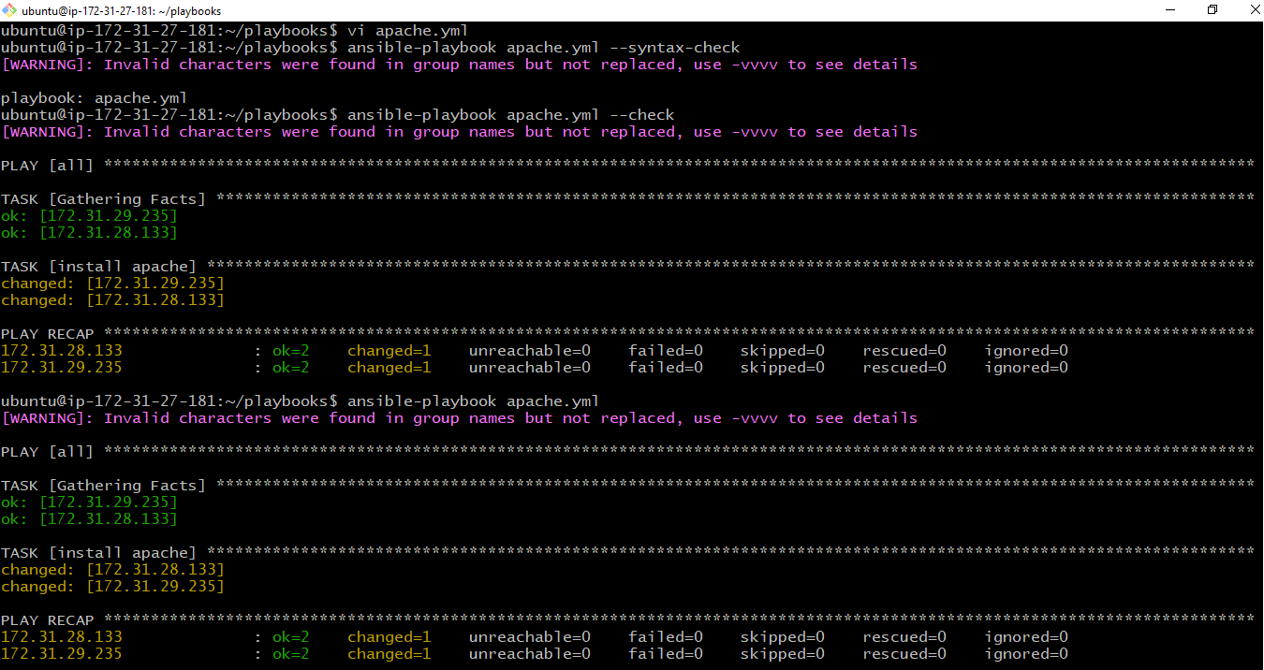
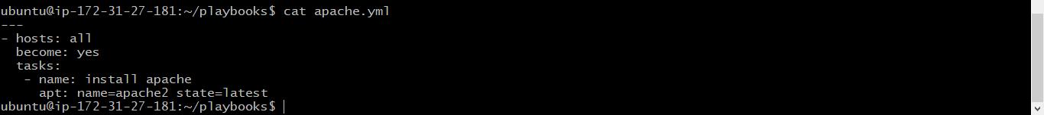
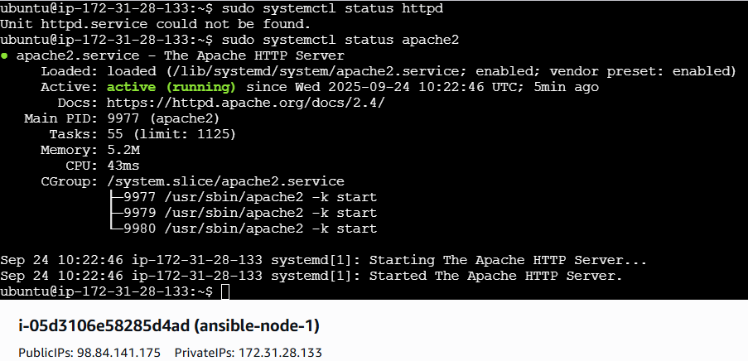
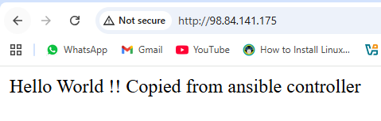
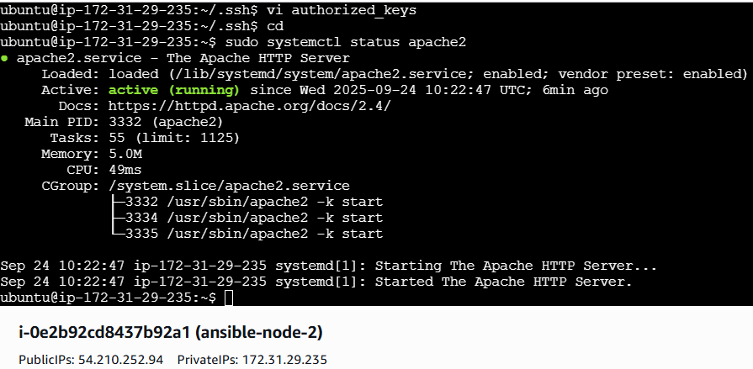
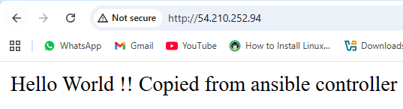
Without changes in the index.file execution not restarted because it is depend on notifiers module
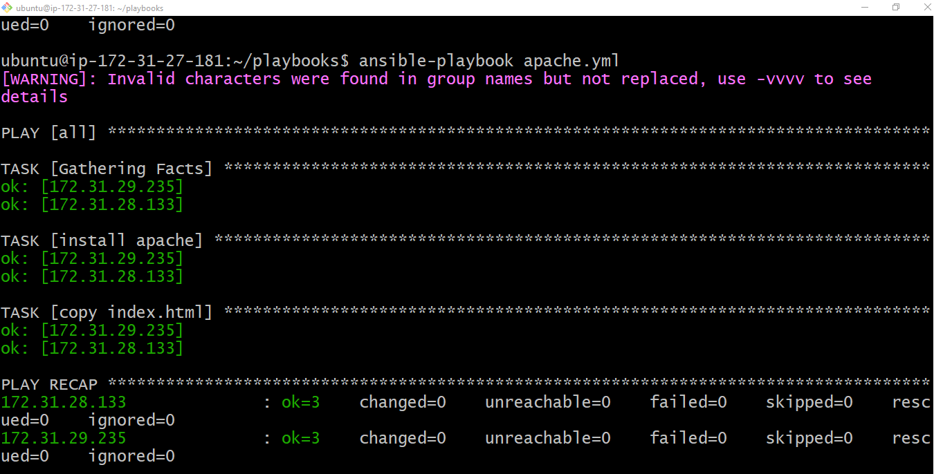
After changes done in index.html file it except dependency and restarted the services
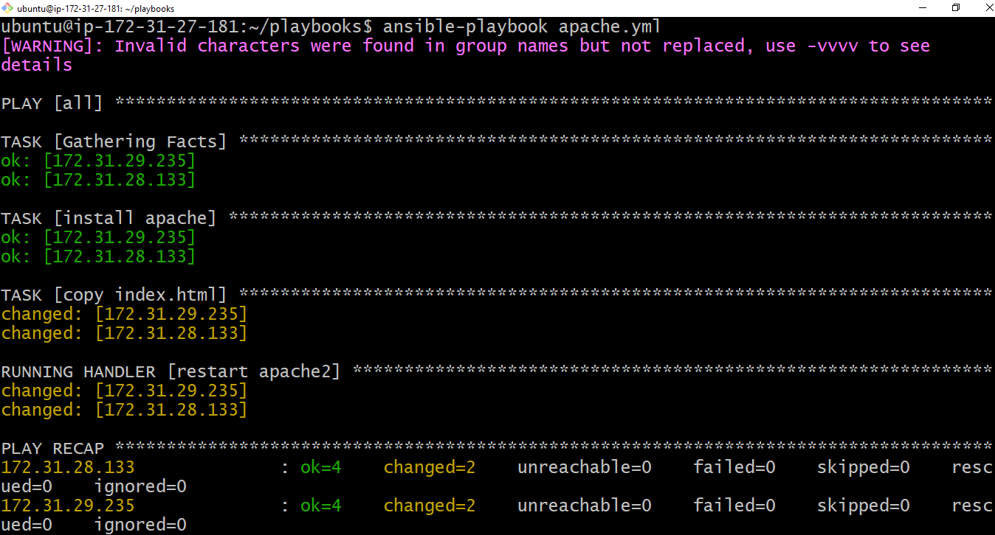
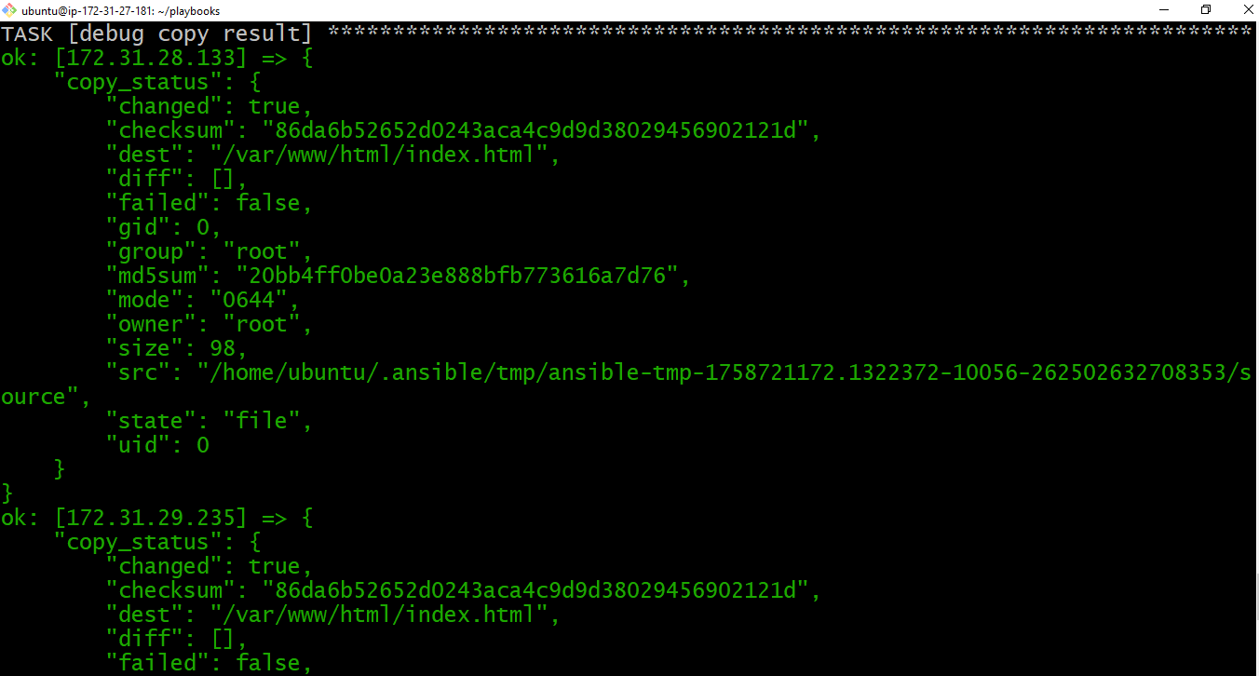
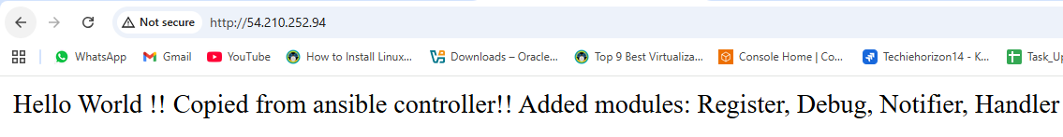
- Write a ansible playbook to install Apache tomcat.
Playbook:
---
- hosts: all
become: yes
vars:
tomcat_major: "9"
tomcat_version: "9.0.109"
tomcat_user: "tomcat"
install_dir: "/opt"
download_dir: "/tmp"
java_package: "openjdk-17-jdk"
java_home: "/usr/lib/jvm/java-17-openjdk-amd64"
tasks:
- name: Install Java 17
apt:
name: "{{ java_package }}"
state: present
register: java_status
- debug:
msg: "Java installed => changed={{ java_status.changed }}"
- name: Create Tomcat user
user:
name: "{{ tomcat_user }}"
shell: /bin/false
register: tomcat_user_status
- debug:
msg: "Tomcat user created => changed={{ tomcat_user_status.changed }}"
- name: Download Tomcat {{ tomcat_version }}
get_url:
url: "https://downloads.apache.org/tomcat/tomcat-{{ tomcat_major }}/v{{ tomcat_version }}/bin/apache-tomcat-{{ tomcat_version }}.tar.gz"
dest: "{{ download_dir }}/apache-tomcat-{{ tomcat_version }}.tar.gz"
mode: '0644'
register: tomcat_download
- debug:
msg: "Tomcat downloaded => changed={{ tomcat_download.changed }} | dest={{ tomcat_download.dest }}"
- name: Extract Tomcat
unarchive:
src: "{{ download_dir }}/apache-tomcat-{{ tomcat_version }}.tar.gz"
dest: "{{ install_dir }}/"
remote_src: yes
register: tomcat_extract
- debug:
msg: "Tomcat extracted => changed={{ tomcat_extract.changed }}"
- name: Rename Tomcat directory
command: mv {{ install_dir }}/apache-tomcat-{{ tomcat_version }} {{ install_dir }}/tomcat
args:
creates: "{{ install_dir }}/tomcat"
register: tomcat_move
- debug:
msg: "Tomcat renamed => changed={{ tomcat_move.changed }}"
- name: Set Tomcat permissions
file:
path: "{{ install_dir }}/tomcat"
owner: "{{ tomcat_user }}"
group: "{{ tomcat_user }}"
state: directory
recurse: yes
register: tomcat_permission
- debug:
msg: "Tomcat permissions updated => changed={{ tomcat_permission.changed }}"
- name: Create systemd service for Tomcat
copy:
dest: /etc/systemd/system/tomcat.service
content: |
[Unit]
Description=Apache Tomcat {{ tomcat_version }}
After=network.target
[Service]
Type=forking
User={{ tomcat_user }}
Group={{ tomcat_user }}
Environment="JAVA_HOME={{ java_home }}"
Environment="CATALINA_PID={{ install_dir }}/tomcat/temp/tomcat.pid"
Environment="CATALINA_HOME={{ install_dir }}/tomcat"
Environment="CATALINA_BASE={{ install_dir }}/tomcat"
Environment="CATALINA_OPTS=-Xms512M -Xmx1024M -server -XX:+UseParallelGC"
ExecStart={{ install_dir }}/tomcat/bin/startup.sh
ExecStop={{ install_dir }}/tomcat/bin/shutdown.sh
[Install]
WantedBy=multi-user.target
register: tomcat_service_file
- debug:
msg: "Systemd unit created => changed={{ tomcat_service_file.changed }}"
- name: Reload systemd daemon
command: systemctl daemon-reload
- name: Start and enable Tomcat
service:
name: tomcat
state: started
enabled: yes
register: tomcat_service
- debug:
msg: "Tomcat running => state={{ tomcat_service.state }} | enabled={{ tomcat_service.enabled }}"
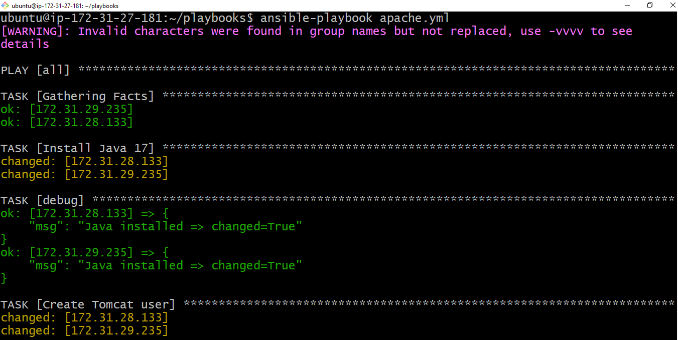
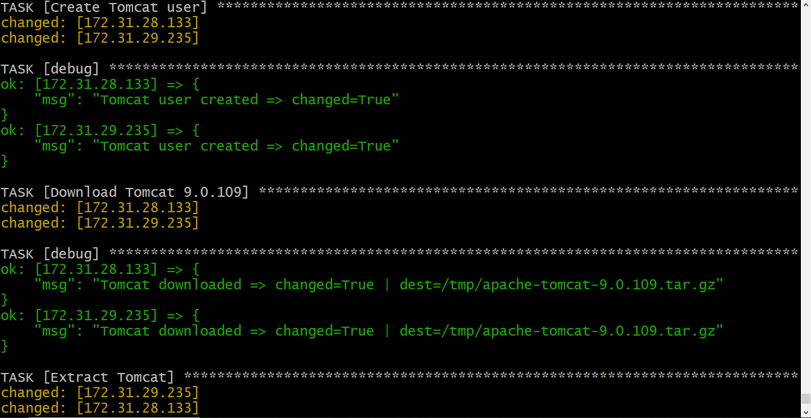
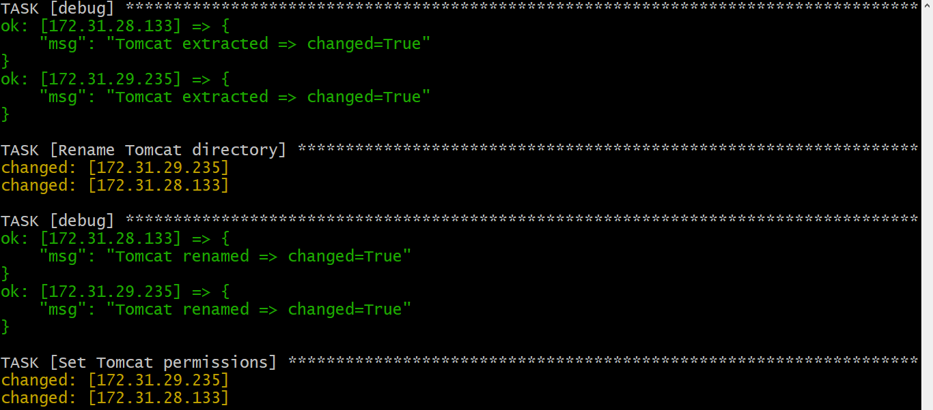
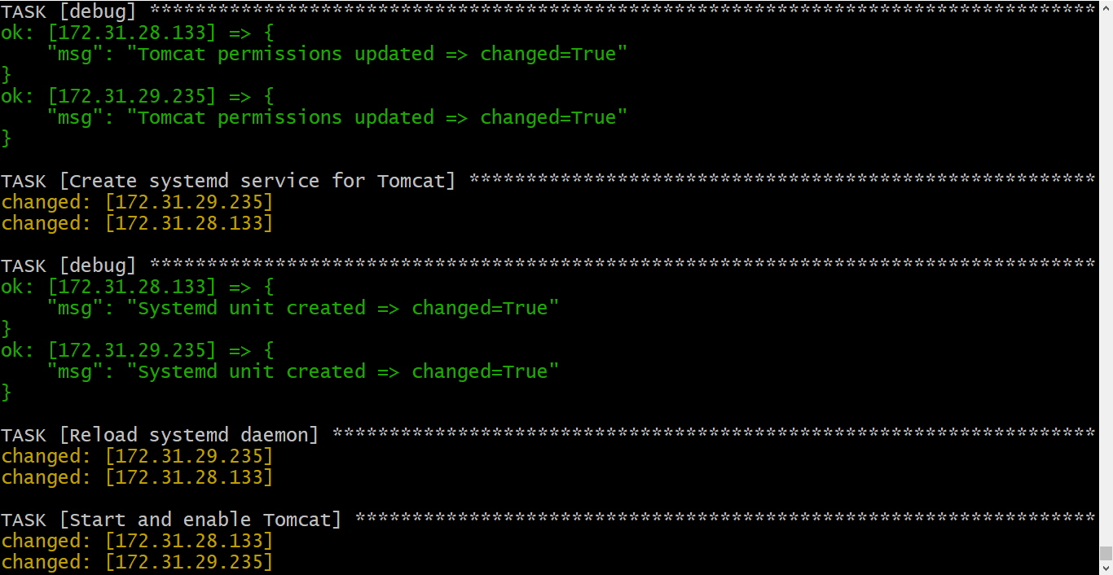
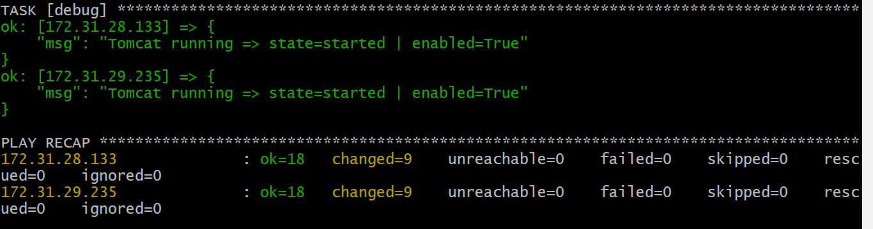
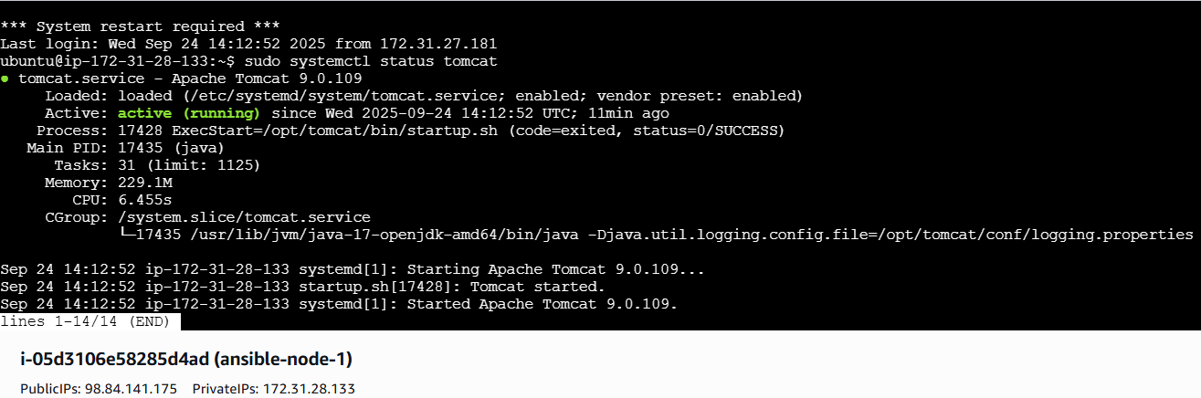
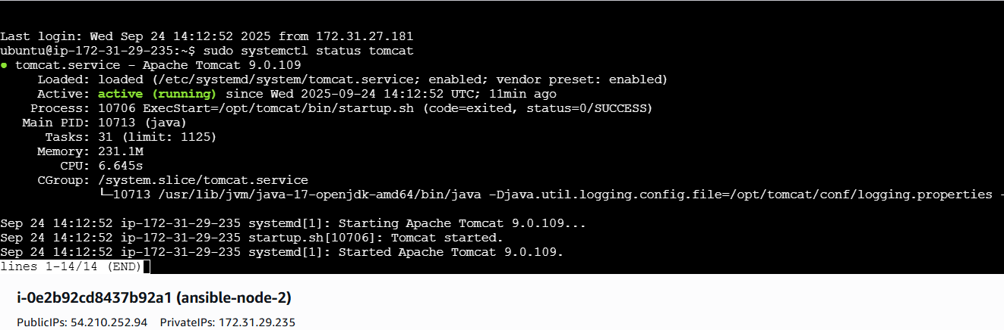

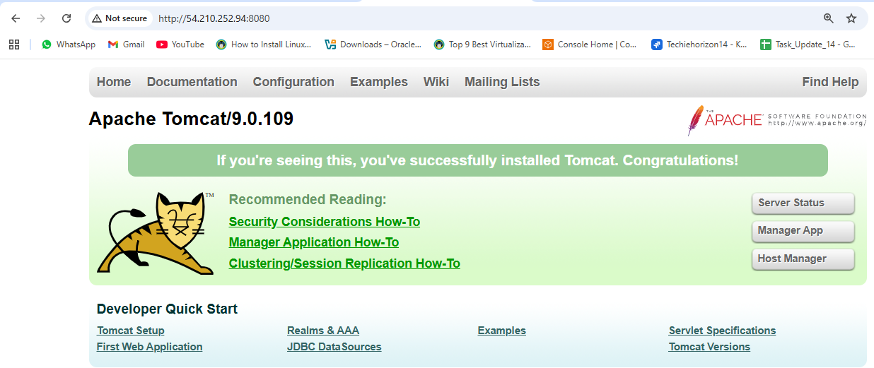
- Write a ansible playbook to provision one ec2 on aws.
Configure AWS Credentials
bash
# Install AWS CLI if not already installed
sudo apt-get update
sudo apt-get install awscli -y

# Configure AWS credentials
aws configure
playbook:
---
- name: Provision EC2 in default VPC
hosts: localhost
connection: local
gather_facts: no

collections:
- amazon.aws

vars:
region: "us-east-1"
instance_type: "t2.micro"
ami_id: "ami-0c02fb55956c7d316" # Amazon Linux 2
key_name: "Virginia" # Replace with your AWS key pair

tasks:
- name: Get default VPC
amazon.aws.ec2_vpc_net_info:
region: "{{ region }}"
filters:
isDefault: true
register: vpc_info

- name: Set default VPC ID
set_fact:
vpc_id: "{{ vpc_info.vpcs[0].vpc_id }}"

- name: Get default subnet of default VPC
amazon.aws.ec2_vpc_subnet_info:
region: "{{ region }}"
filters:
vpc-id: "{{ vpc_id }}"
register: subnet_info

- name: Pick first subnet
set_fact:
subnet_id: "{{ subnet_info.subnets[0].subnet_id }}"

- name: Create security group in default VPC
amazon.aws.ec2_group:
name: ansible-sg
description: Security group for Ansible EC2
vpc_id: "{{ vpc_id }}"
region: "{{ region }}"
rules:
- proto: tcp
ports: [22]
cidr_ip: 0.0.0.0/0
- proto: tcp
ports: [80]
cidr_ip: 0.0.0.0/0
register: sg

- name: Launch EC2 instance in default VPC
ec2_instance:
name: "ansible-ec2-demo"
key_name: "{{ key_name }}"
instance_type: "{{ instance_type }}"
image_id: "{{ ami_id }}"
region: "{{ region }}"
vpc_subnet_id: "{{ subnet_id }}"
security_group: "{{ sg.group_id }}"
wait: yes
tags:
Name: "ansible-ec2-demo"
Environment: "Dev"
register: ec2

- name: Show EC2 instance public IP
debug:
msg: "EC2 instance launched with public IP: {{ ec2.instances[0].public_ip_address }}"

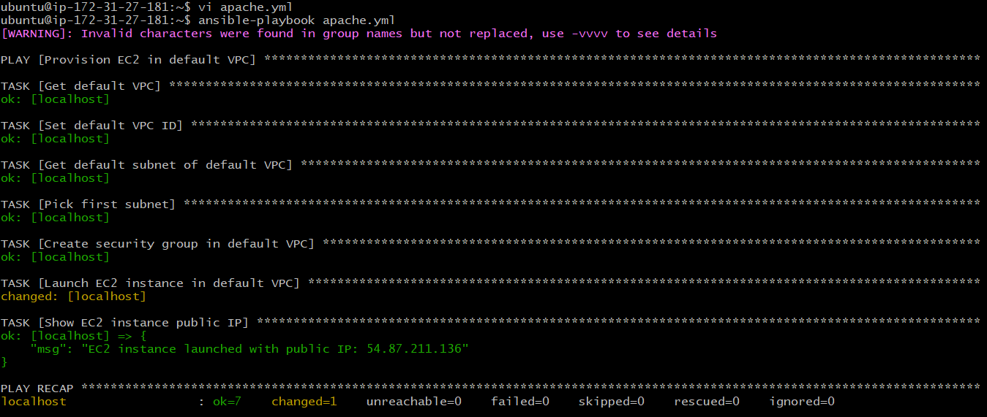
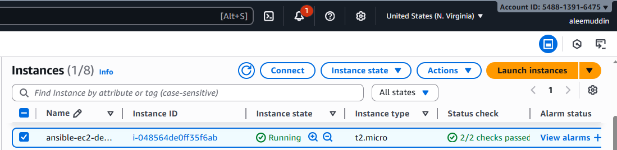
- Write a ansible playbook to copy one file from node-1 to node-2.

How it works:
- fetch pulls the file from node-1 to your control machine (Ansible host).
- copy then pushes it from the control machine to node-2.
- delegate_to: node-2 tells Ansible to run the copy on node-2.
Notes:
- Replace /path/to/source/file.txt with the actual file path on node-1.
- Replace /path/to/destination/file.txt with the desired path on node-2.
- Ensure SSH connectivity from the control node to both node-1 and node-2.
Playbook:
---
- name: Copy a file from node-1 to node-2
hosts: node-1
gather_facts: no
tasks:
- name: Fetch file from node-1 to control machine
fetch:
src: /home/ubuntu/file.txt # file on node-1
dest: /tmp/ # temporary location on control machine
flat: yes
- name: Copy file from control machine to node-2
copy:
src: /tmp/file.txt # file fetched from node-1
dest: /home/ubuntu/file.txt # destination on node-2
delegate_to: 172.31.29.235
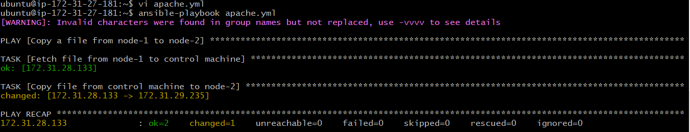
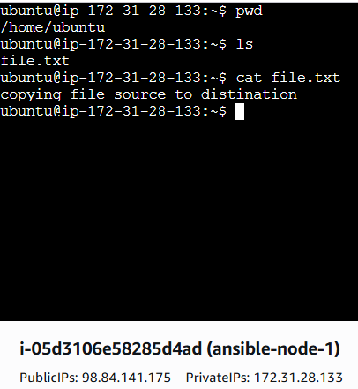
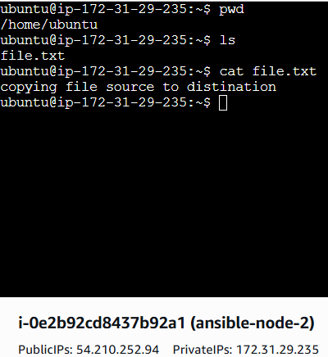
- Write a ansible playbook to create different files with different names using single playbook.
How it works:
- files_to_create: A list of dictionaries, each containing:
  - name → the file name
  - content → what goes inside the file
- loop: Iterates over the list and creates each file using the copy module.
- Destination folder: Currently /tmp/, but you can change it to any directory.
Playbook:
---
- name: Create multiple files with different names
hosts: all
become: yes
gather_facts: no
vars:
files_to_create:
- name: file1.txt
content: "This is content for file 1"
- name: file2.txt
content: "This is content for file 2"
- name: file3.txt
content: "This is content for file 3"
tasks:
- name: Create files with different names and content
copy:
dest: "/tmp/{{ item.name }}"
content: "{{ item.content }}"
loop: "{{ files_to_create }}"

